**Assignment -2**

Digital Marketing

|  |  |
| --- | --- |
| Student Name : | Thiru Selvam T |
| Student Roll Number : | 20URCS049 |
| NM ID : | 97C6EB5A9F3EB30ADCB434840EE2B86C |
| College Name : | AAA College of Engineering and Technology |

**QUESTION:**

**Create a New Facebook Business Page and post one social media poster for your brand.**

**FACEBOOK BUSINESS PAGE :**

**Page Link :** [**https://www.facebook.com/profile.php?id=61550651903105&mibextid=ZbWKwL**](https://www.facebook.com/profile.php?id=61550651903105&mibextid=ZbWKwL)

**Blog Title: Luffy Crackers**

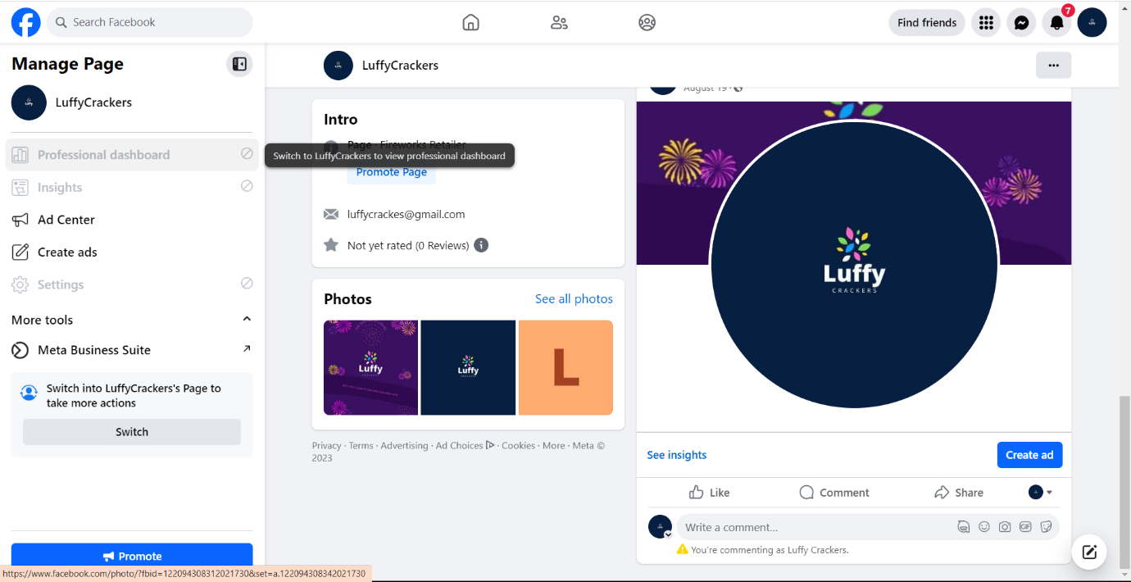

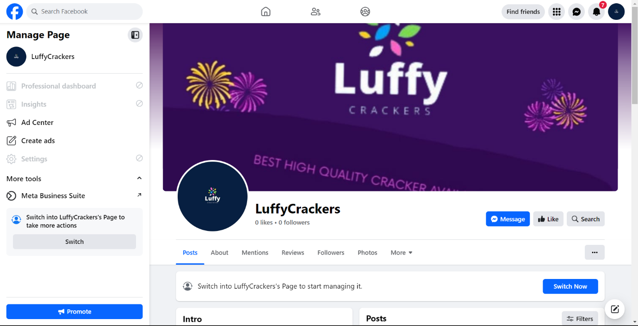

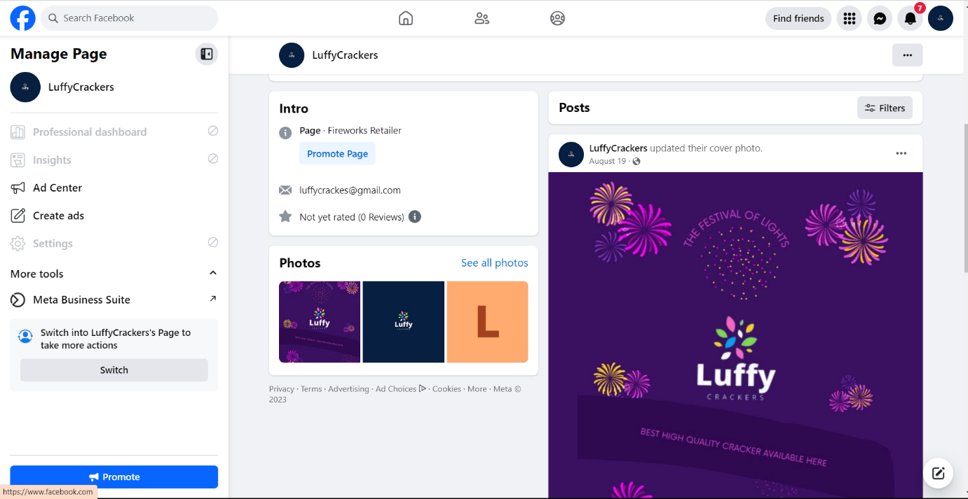

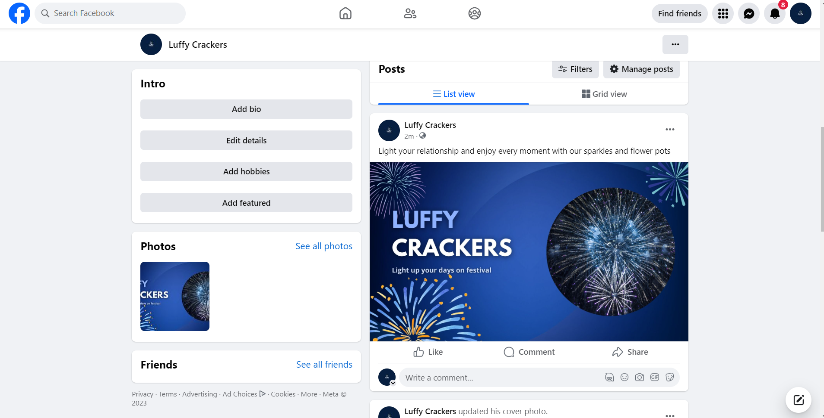



**SOCIAL MEDIA POSTERS :**



